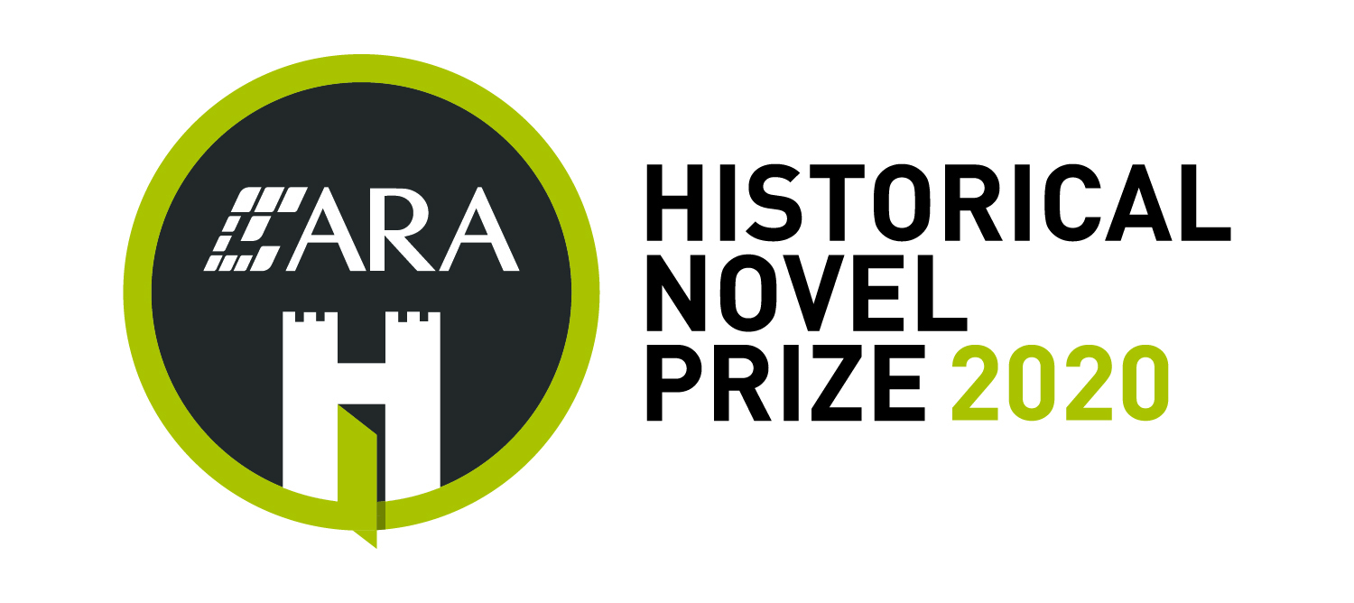

2020 ARA Historical Novel Prize Nomination Form

Book and Author details
Title of book:
Author:
ISBN:
ASIN/ePub ISBN: (if applicable)
Date and place of publication:
Short summary/blurb of book (no more than 120 words)

Place of citizenship or residency of author:
Publisher:
Trybooking ticket number for entry fee of $30 (please attach receipt):
Date of Birth of Author (if applicable)*:
*If the book is entirely set post 1970 please provide date of birth of the author (this does not apply to time slip, parallel narratives, multi time narratives, and pseudo histories).

Nominator and contact details (whether publisher, agent or author)
Nominator’s name:
Email address:
Phone number:
Website (if applicable):
Social media handles (if applicable):
Addresses for submission
If in paperback format, four copies of each title entered must be sent to:
ARA Historical Novel Prize
c/o The New England Writers’ Centre,
PO Box 1219, Armidale NSW 2350

If in digital format, both a MOBI and a PDF or EPUB file of the published title must be sent to the digital receiving email address ARAHistNovelPrize@gmail.com
This file must be the final, published version, not a proof copy or manuscript.

Nomination form and receipt to accompany a submission
The nomination form and a copy of the Trybooking receipt must accompany each title submitted. If multiple tickets have been purchased through one Trybooking transaction, then please provide a copy of the receipt with each nomination form.
If submitting the nomination form via email, please rename the form by including the book title and author surname in the file name.
Impact of COVID 19 on postal services
HNSA recognises that postal delays may occur due to the impact of COVID19 restrictions on the Australian and New Zealand postal services. Leeway for late lodgement will be allowed for entries received after the deadline provided the post office time stamp pre-dates 30 June 2020. It is recommended that nominators keep a tracking ID number as proof of postage.
After the close of submissions, HNSA will reconcile Trybooking ticket transactions against the list of titles lodged. If a title has not been received, HNSA will contact the nominator to ascertain when and from where the entry was sent. Please do not contact HNSA to seek confirmation of receipt of an entry.

_____________________________
Signature of nominator (a typed name is acceptable):

Date nomination form signed:______________________

Tickets can be purchased via Trybooking
Contest rules are available on the HNSA website

