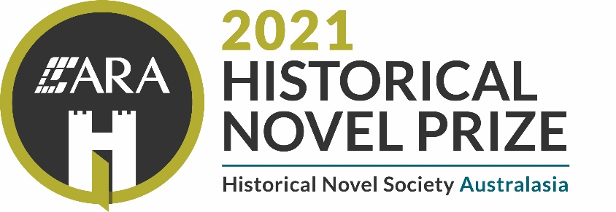

2021 ARA Historical Novel Prize Nomination Form

Book and Author details
- Title of book:
- Author:
- ISBN:
- EPUB ISBN: (if applicable)
- Date and place of publication:
- Place of citizenship or residency of author:
- Publisher:
- Link to a digital sales platform on which the book is available for sale (or on presale with a release date on or before 30 June):

Trybooking the 8 digit ticket number for entry fee of $35 (Early bird) or $50 (general entry) - please attach ticket:
Early bird period: 14 April to 14 May (midnight) 2021
General period: 15 May to 14 June (5pm) 2021
Nominator and contact details (whether publisher, agent or author)
- Nominator’s name:
- Email address:
- Phone number:
- Website (if applicable):
- If you are a publisher submitting a book on behalf of an author please confirm the author’s consent by providing personal email contact details for the author:

Addresses for submission
If in paperback format, three copies of each title entered must be sent to:
ARA Historical Novel Prize
c/o The New England Writers’ Centre,
PO Box 1219, Armidale NSW 2350

www.newc.org.au/ara-historical-novel-prize.html

If in digital format, an EPUB file of the published title must be sent to the digital receiving email address ARAHistNovelPrize@gmail.com by way of attachment. No Cloud transfers are accepted.
This file must be the final, published version, not a proof copy or manuscript. No other format is acceptable.

Nomination form and receipt to accompany a submission
The nomination form and a copy of the Trybooking receipt must accompany each title submitted by emailing to ARAHistNovelPrize@gmail.com by way of attachment. If multiple tickets have been purchased through one Trybooking transaction, then please provide a copy of the receipt with each nomination form.
NB When submitting the nomination form via email, please rename the form by including the book title and author surname in the file name.
Impact of COVID 19 on postal services
HNSA recognises that postal delays may occur due to the impact of COVID19 restrictions on the Australian and New Zealand postal services. Leeway for late lodgement will be allowed for entries received after the deadline provided the post office time stamp pre-dates 14 June 2021. It is recommended that nominators keep a tracking ID number as proof of postage.
After the close of submissions, HNSA will reconcile Trybooking ticket transactions against the list of titles lodged. If a title has not been received, HNSA will contact the nominator to ascertain when and from where the entry was sent. Please do not contact HNSA to seek confirmation of receipt of an entry.
It is highly recommended that nominators submit their entries well in advance of the closing date to avoid issues with postal delays.

_____________________________
Signature of nominator (a typed name is acceptable):

Date nomination form signed:

Tickets can be purchased via Trybooking
Adult category- https://www.trybooking.com/events/landing?eid=737669
CYA category- https://www.trybooking.com/events/landing?eid=737675
Contest rules are available on the HNSA website https://hnsa.org.au/ara-historical-novel-prize/

